# Lab 6 Week 7

1. An example of span in my folder is a message form Nintendo about how they are upgrading Super Mario Run. To find the original server and the IP you click the arrow beside the reply button and you are given a drop down list. In this drop down list, you are given an option to show original. This gives us a lot of information including Message ID and created time. More importantly it gives us an IP address. We can then go on the site <http://whatismyipaddress.com> and enter in the IP from the spam email. We are then given the fallowing information about that IP address.

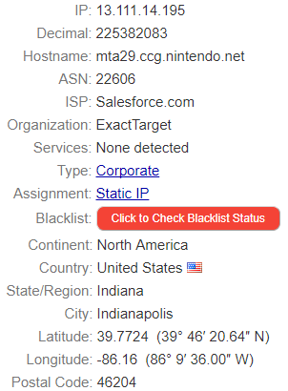

1. Due to Web Historian being incompatible with windows ten I could not install it. However, I have completed research on the tool. Web Historian is a piece of software the allows you check your internet, cookies and what has been downloaded. This is a great tool for forensic analysis. You can export the results of the scan and store them as HTML, XML or as a CSV file. This software gives us information on the user’s profile and what their internet search habits are. We can see what browser they are using and what version it is on. The username of the user is also displayed here. We can see how many times the user has visited a site and when was the last time a specific site has been visited. You can filter for specific search results you want to see. To do this we use the Scan button to open up the web history scan window. When the scan is complete you are given all the information of you web history or what you have filtered out. We can view this information in the form of graphs of the user’s choice bar charts or pie charts. Of course, we can view this as a list too. Below we can see an example of web historian.

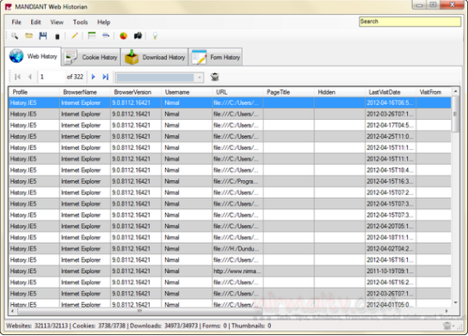

***References:***<http://www.softpedia.com/get/Security/Security-Related/Web-Historian.shtml>  
  
<http://www.makeuseof.com/tag/web-historian-monitor-analyse-history-installed-web-browsers/>